

Vel Tech Rangarajan Dr. Sagunthala R&D Institute of Science and Technology
School of Computing
Department of Computer Science and Engineering
10211CS224 / FULL STACK APPLICATION DEVELOPMENT (JAVA)
PROJECT REVIEW : MILESTONE PROJECT – 1
Date: 30-03-2026
Subscription-Based Membership Engine with Tiered Logic
SDG: SDG No 9 – SDG Title(Industry, Innovation and Infrastructure)
Presented By: Courses Handling Faculty:
SHAIK MAHAMMAD SIRAJ– VTU26546 – 23UECS0880 Dr-Hafizur Rahman/ ASSISTANT PROFESSOR

INTRODUCTION
- Many online platforms today use subscription models to provide different levels of services to users. Managing user registration, login, and subscription plans efficiently is an important challenge for such systems and without this managing it becomes difficult
1
4
2
5
3
7
6
8
9
to track which user has selected which plan.
- This project aims to solve that problem by creating a structured subscription management system by allowing users to register, log in, and choose a suitable
subscription plan.
- The selected plan is stored securely in a database for future access and management.
- This approach improves organization, reliability, and user experience in the platform.
- Overall, the project demonstrates how a simple web application can effectively manage user subscriptions.

PROBLEM STATEMENT
- Many online platforms offer multiple subscription plans, but managing them efficiently
can be difficult.
- Users often face confusion when registration, login, and plan selection are not properly
connected.
5 ➢ Without a proper system, storing and tracking user-selected plans becomes challenging.
2
4
1
3
7
6
8
- This can lead to errors in providing the correct services to users.
- There is a need for a simple and organized system to manage user subscriptions.
- The project focuses on creating a web-based platform for user registration and login.
- It allows users to select a subscription plan and stores the details in a database.
- The system ensures a smooth, secure, and user-friendly experience.

OBJECTIVES
- To design and develop a web-based user subscription system that allows users to
3
4
1
5
2
7
6
8
register, log in, and select different subscription plans.
- To implement database integration for securely storing and managing user details and their selected subscription plans.

PROPOSED SYSTEM
- A web-based subscription management system is developed where users can easily register, log in, and select a suitable subscription plan.
- The system stores user details and selected plans in a centralized database, making data management organized and secure.
- It provides a simple and user-friendly interface so users can complete registration and plan selection without confusion and automatically updates the user’s subscription plan in the database after selection.
4
3
1
5
2
7
6
8
- Session management is used to track users during registration and plan selection, ensuring correct data processing.
- It reduces manual data handling errors by automating the registration and subscription process.
- The platform allows quick access and easy modification of user information when required.
- Compared to traditional manual systems, it is faster, more reliable, and improves overall efficiency of managing user subscriptions.
PROPOSED SYSTEM ARCHITECTUR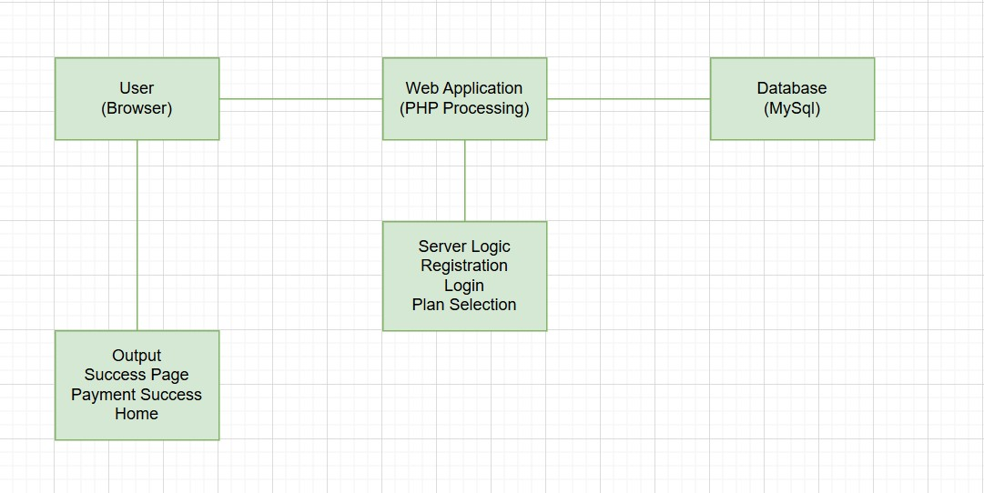
5
3
1
4
2
7
6
8

WORKFLOW
6
3
1
4
2
7
5
8

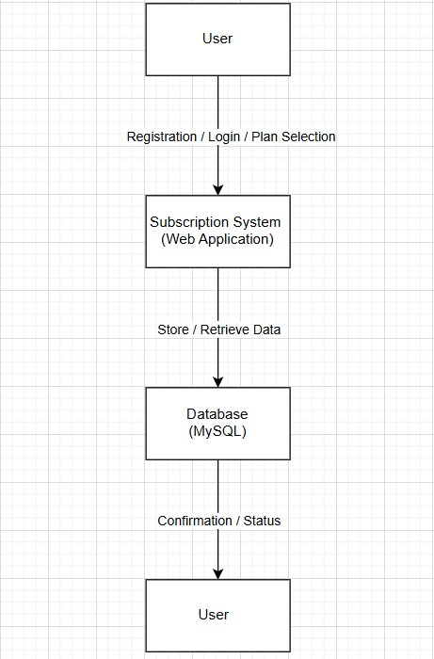
TECHNOLOGIES USED
Frontend:
- HTML – To create the structure of web pages.
- CSS – To design and style the user interface.
- Bootstrap – For responsive and attractive UI design.
- JavaScript – For form validation and basic client-side functionality.
Backend:
- PHP – To handle server-side logic such as registration, login authentication, session management, and subscription plan processing.
7
3
1
4
2
6
5
8
Database:
- MySQL – To store and manage user details, login credentials, and selected subscription plans.
Tools:
- XAMPP – Local server environment to run PHP and MySQL.
- Visual Studio Code / Notepad++ – Code editor for development.
- Web Browser (Chrome/Edge) – For testing and running the application. Hardware/Software Requirements:
- Hardware: Computer/Laptop with minimum 4GB RAM and internet connectivity.
- Software: Windows OS, XAMPP Server, Web Browser, and Code Editor (VS Code or similar).
MODULE DESCRIPTION

Module 1: User Registration & Login
Handles user registration and login functionality. It allows new users to create an account and existing users to securely log in using their email and password.

Module 2: Subscription Plan Selection
Allows users to choose a suitable subscription plan such as Free, Standard, or Premium. The selected plan is processed and linked to the user account.
8
3
1
4
2
6
5
7

Module 3: Database Management
Manages storing, updating, and retrieving user details and subscription information in the MySQL database while ensuring data consistency.

Module 4: Payment & Confirmation
Processes the selected subscription plan and displays confirmation pages such as payment success or plan activation to inform the user about the successful completion of the process.

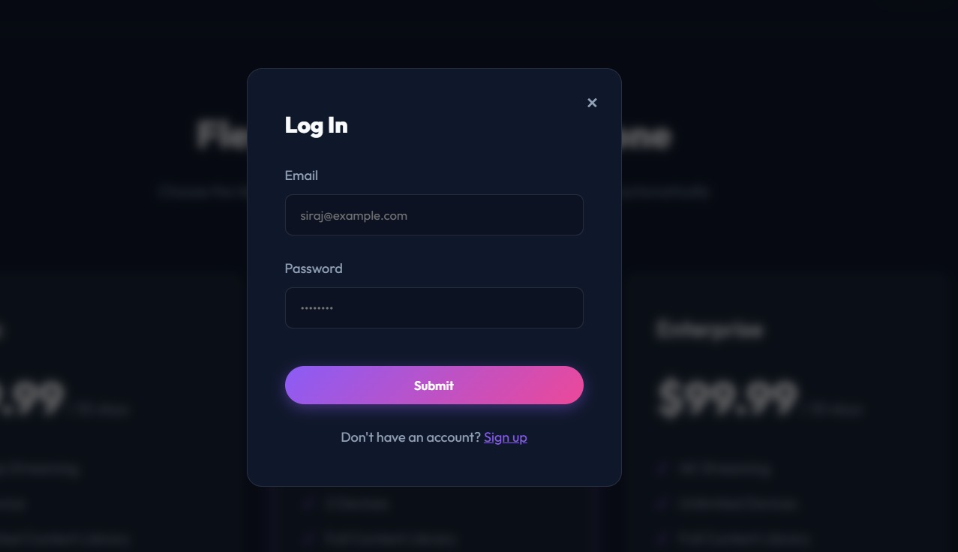
The above slide is the home page of this web

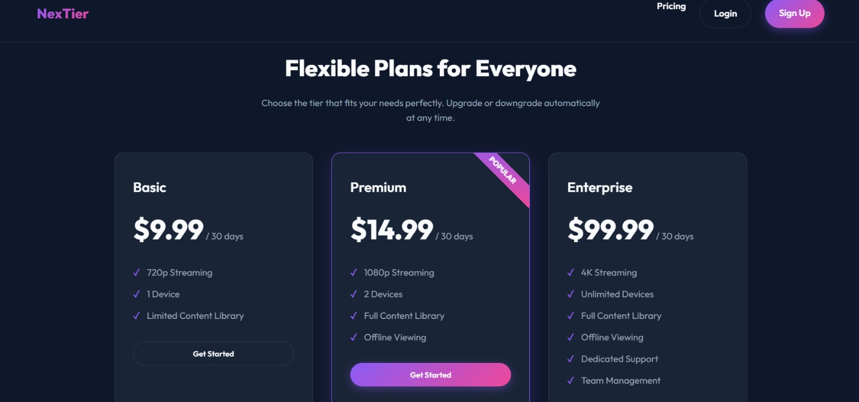
site where if the user doesn’t have an account they can register first and continue reading. If the user have an account then they can directly login to their selected plan.

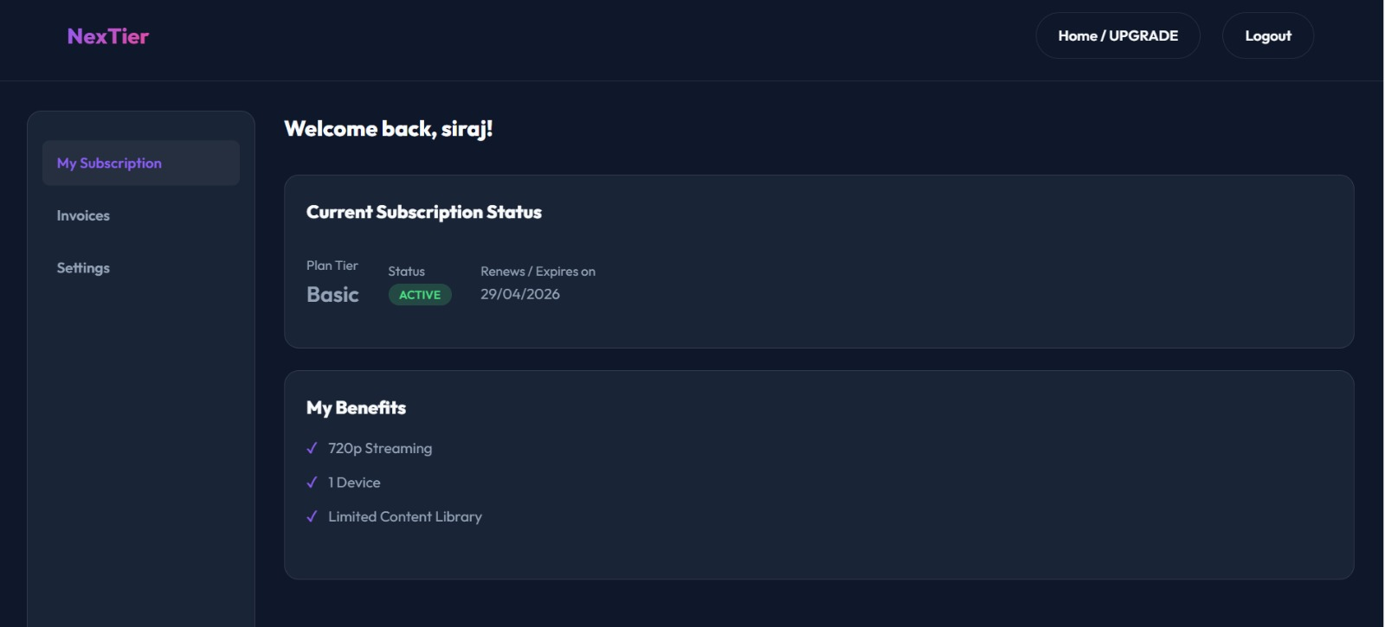

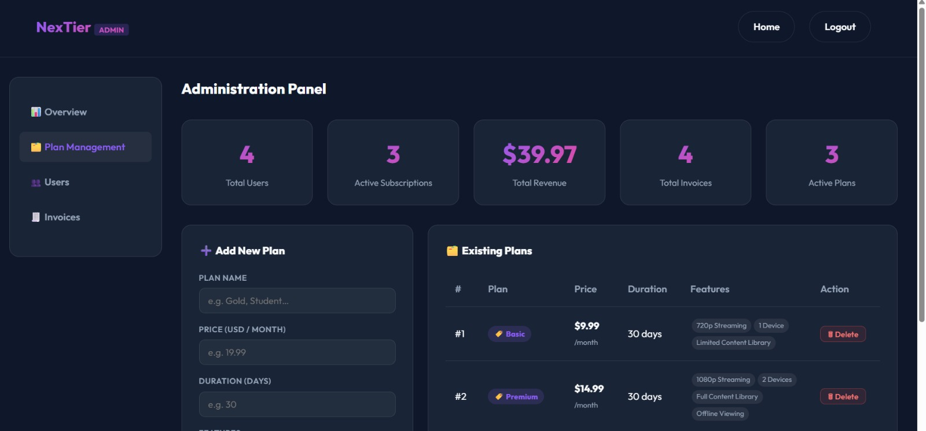

ADVANTAGES & LIMITATIONS
Advantages:
- Provides a simple and user-friendly interface for registration, login, and plan selection.
- Helps in efficient management of user subscriptions and account details.
- Stores data in a centralized database, making it easy to manage and retrieve user information.
- Reduces manual work and errors by automating the subscription process.
- Allows users to choose different plans (Free, Standard, Premium) based on their needs.
9
3
1
4
2
6
5
7
8
- Improves the overall user experience with smooth navigation and confirmation pages.
Limitations:
➢The system is designed for basic subscription management and does not include real online payment gateways.
➢It currently supports limited security features, which can be enhanced for real-world applications.
➢The system is intended for small-scale use and may require further optimization for large numbers of users.

Thank you

